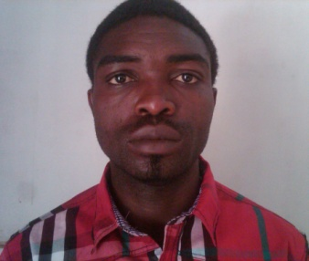
Mahason Michael Solomon
NO. 37 NDA Road Kurmin Mashi Kaduna, Kaduna State
07033701677, 08098996674, 08026908330
PERSONAL DATA
Place of Birth - Kaduna
Date of Birth - 6th June, 1985
Gender - Male
State of Origin - Kogi
Local Govt.Area - Ankpa
Nationality - Nigerian
Marital status - Single
Religion - Christianity

SCHOOLS ATTENDED WITH DATE
- Kaduna Polytechnics (Kadpoly) 2010 – 2013
- Kaduna Polytechnics (Kadpoly) 2005 – 2008
- Hope Secondary School Kaduna 2003 - 2005
- Government Secondary School Ungwan Sarki Kaduna 1999 - 2003
- L.G.E.A Primary School Odagbo Kogi State 1990 - 1996

QUALIFICATIONS OBTAINED WITH DATE
- NYSC Discharge Certificate 2013
- Higher National Diploma (HND) In Computer Science 2012
- National Diploma (ND) In Computer Science 2008
- Senior Secondary school Certificate Examination 2005
- First School Leaving Certificate 1996

WORKING EXPERIENCES
- NYSC : Lecturer
Federal Collage of Forestry Mechanization Afaka – Mando Kaduna 2013
- Mufnaj Global
Kaduna State University (KASU) 2012
- Nigeria Air force Base Kaduna
One year Industrial Attachment on Computer Maintenance 2009

OBJECTIVES
- To work tirelessly towards achieving organizational goal.
- To ensure successful completion of a given task.
- To promote the increase and development of the organization.
- To enhance the workforce and increase the financial status of the organization.
LANGUAGES SPOKEN
Igala, Yoruba, Hausa and English.

HOBBIES
Reading, Travelling, and watching sports.
REFEREES
Audiologist Danlami A. Eneche
Christabell Blinded Mission,
No. 34 Okemesi Crescent,
Garki II, Abuja.
08035996161

Mr. Haruna Ishaya
Executive Officer Admin,
Federal College of Forestry Mechanization,
Afaka – Kaduna.

F.S. Femi Orukotun
Nigerian Air force Base Kaduna
Kaduna

